Do We Really Need a New Mythology?
Craig Chalquist
Chalquist.com
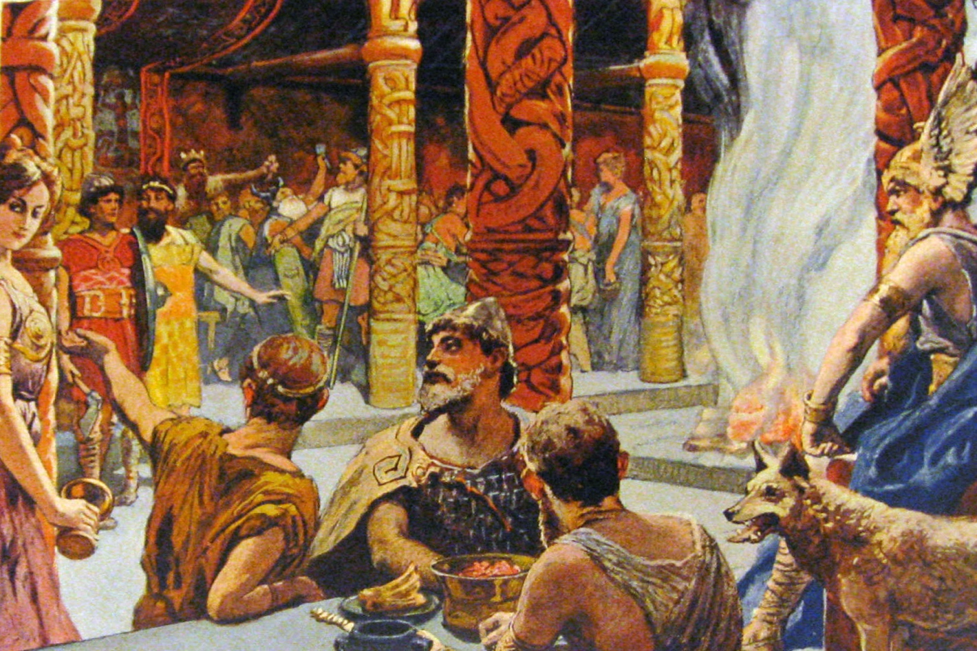
Painting of gods messing about in Valhalla.
A New Myth for Our Time?
In his thoughtful and beautifully reflective book The Dream of the Earth, “geologian” Thomas Berry makes two claims I have always found problematic: that the big story we told ourselves about our place in the universe no longer works, and that we need a new story.
By big story he means the religious cosmology popularized by the church during the Middle Ages, when Earth was the center of everything and angels flew above us in the sky. This story worked for some, but certainly not all. It was Christian, and most of the world wasn’t, including esoterics whose Hermetic images of a central Sun and a moving Earth eventually worked their way into Copernican cosmology.
Do we need a new big story? Sure enough, the old one cracked centuries ago, for most of us anyway, and the accounts of materialist science have disenchanted the cosmos into mute rubble. Berry, Brian Swimme, and others have given us a chance at reenchantment by reimagining the Big Bang “flaring forth” as an event of universal wonder. I love hearing Brian talk about how star dust from supernovae creates things, including soils, elephants and us.
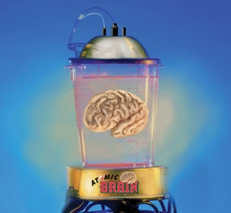
My first concern about the idea our needing a new big story is that really big stories tend to harden and oppress. One reason for this is that they are told by people with the power to do the telling and interpreting and to impose their frameworks and beliefs on everyone else. Historically, where we hear a big story, we also hear, if we listen carefully, a multitude of silences: voices shut down by what some spellbound majority accepts. A big story of the Age of Exploration was that indigenous people made good slaves. A big story of the Enlightenment exalted reason as men understood it above intuition and feeling. One result was two World Wars; another was a planetary biosphere all but wrecked by industrialized machinery. It was invented by rationalists who split technique from morality so they could sleep at night.
My second concern is that if by “big story” we mean a new mythology in which gods etc. are taken literally, such pantheons have a way of turning into religions. Do we need a new official religion, perhaps a worldwide religion? A religion is a collection of sacred stories—a “mythology” in the non-pejorative sense of that word—bundled into an institution, with rituals, titles, songs, and so on. Is that what we need? What about those of us who are allergic to official religion? And again: Who gets left out? What happens when the powerful and persuasive start deciding who is a believer and who a heretic? A religion can be thought of as a collective spiritual power source easily hijacked by the ambitious.
My third concern with the big story idea is that science is not a story, it’s a method for testing knowledge. Scientists are not storytellers by career, although some have learned to be. Jeffrey Kiehl, who is both a climate scientist and a Jungian analyst, begins his climate awareness presentations by telling the story of mad King Erisychthon, who logged down all the trees in his kingdom to build a grand palace. For this, Nemesis cursed the king with insatiable hunger. That is a story. Data are not, although influential stories can contain plenty of data.
So I cannot agree with Joseph Campbell when he points to modern science as fulfilling the cosmological function of mythology. The stories we weave about what the science means are another matter. (Maybe that’s what he meant.)
Speaking of Campbell, in his Power of Myth interview with Bill Moyers they discussed the possibility of Earthrise serving as a new mythic image for our time. Mythic image, yes. Mythology, no. Campbell observed more than once in his books that traditional mythologies, questioned by the Scientific Age and detached from their cultures of origin, lay in fragments.
The fragments follow us, which is why we can’t ignore myth altogether. Myth is like history: being ignorant of it ensures its replays. The myth of the Golden Age echoes in conservative appeals to return to the Good Old Days (for white people); the fiery river Phlegethon returns whenever an oil spill ignites on a river; the Golem stares back at us from our monitors; the mythic motif of leaving the body for heaven returns in transhumanist attempts to upload human consciousness onto the Internet. We can perhaps do without belief in a mythology, but we cannot escape myth.
Campbell and Berry knew that cultures deprived of their core stories tend to fragment along with their mythologies. If a new mythology or religion along traditional lines won’t serve, what will?
Suspending Disbelief
Some years back, at the request of his mother, I took a boy to a Star Trek convention. He and I liked the show and often watched it together. Neither of us identified as Trekkers. He wanted to go, though, so we went. It was in Los Angeles.
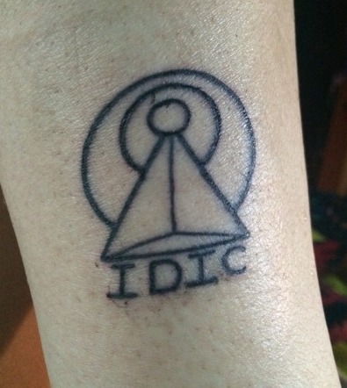
We saw what we expected to see: lots of people in costumes, with actors mixed in. Amusing speeches. Tables filled with combadge and phaser replicas. As I watched participants interact, it dawned on me that here was a group of people from many nations joined by common emblems, desires, optimisms, and philosophies, above all the Vulcan philosophy of IDIC: Infinite Diversity in Infinite Combinations.
No common language (not everyone spoke English), belief, religion, family of gods, self-authorized priesthood, or any of that. Nobody took Star Trek philosophy literally. They did not believe it; but they believed in it.
Stories taken literally are about small-t truths. What “really” happened. Facts. Data. This kind of truth is important; banishing it with lies warps our sense of reality. Faith stories taken literally are not about facts or data, but about belief. Humanity began with Adam and Eve because the Bible says so. (The Bible says a lot of things nobody takes seriously: executing your neighbor for breaking the Sabbath, for instance. The Bible might be the most cherry-picked book in history. But let’s go on.)
Storytelling as imaginative craft is not centrally concerned with either fact or belief. Instead, it creates a secondary world (Tolkien’s term) we can romp around in together. It does this even when we absorb the story by ourselves. When at home alone I read the scene in Gaiman’s American Gods in which Lucy, a face of the god of television, asks Shadow if he ever wanted to see her tits, and he growls, “Not really” as the TV shuts off, my chuckle joins thousands of others. The resonance is even more powerful when we occupy the same space listening, let us say, to Prospero weaving festive spells, Theoden encouraging his fearful riders, or Michael Burnham risking everything to lead USS Discovery, and us, to the 29th Century.
In the film The Illusionist, a stage magician puts on phony seances in which ghosts imply they’ve been murdered by the magician’s enemy, the ferocious Crown Prince Leopold of Austria. When the police threaten to shut down the theater, the magician appears in public to emphasize that what he does is mere entertainment: he can’t really raise the dead. Nevertheless, the shows continue to draw increasingly passionate crowds, prompting one police officer to exclaim to another, “They don’t seem to care that it’s a trick.” Indeed.
Very often, believing in is more powerfully motivating than believing. Effective storytelling may or may not deploy facts or data or even belief, but to work, whatever its medium, it must address the big-T truths of our existence, including the struggles we all face and try to overcome. Not the truths we can calculate or that we are told are true, but the Truths we actually live.
The Folkloresque
In 1950, Richard Dorson coined “fakelore” to protest the commercialistic invention of tales and characters sold as folkloric. Examples of fakelore include Paul Bunyan, thought up and promoted by a logging company, and Rudolph the Red-Nosed Reindeer, part of a sales campaign.
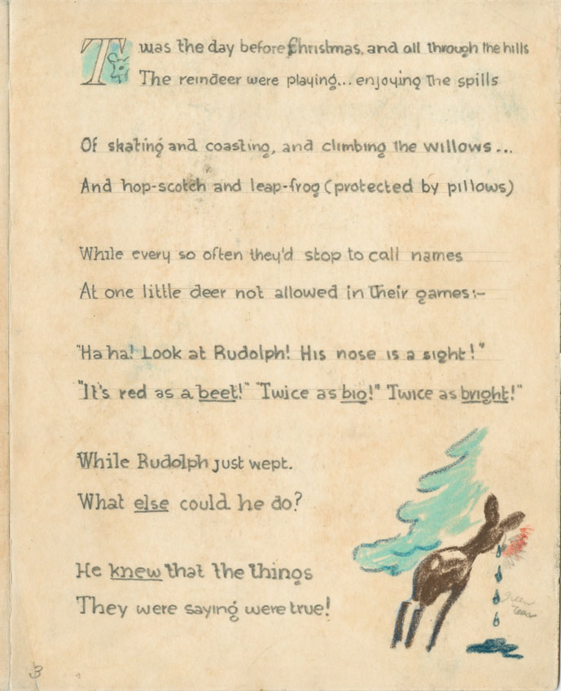
A page from the 1939 Rudolph booklet written for Montgomery Ward.
Star Trek isn’t fakelore, having no pretense of being folklore of any kind, but it is a most lucrative franchise. One that Paramount Pictures now guards jealously, as the fans who filmed Prelude to Axanar discovered. Likewise with Marvel and Disney. Most of us have heard of The Lord of the Rings, but few have heard of Middle-earth Enterprises, who will sue writers or filmmakers who include LOTR characters in books or movies. The productions of all these enterprises brim with folkloric motifs and mythic images. In the real world of hard revenue and bottom lines, fantasy pays.
In 2015, Michael Dylan Foster and Jeffrey A. Tolbert published the edited volume The Folkloresque in part to clarify these issues even while complexifying them. Folklore and popular culture, they argued, sometimes blur into each other. The productions mentioned above are all examples of the folkloresque: the incorporation of folkloric elements into commercial works, and from there back to the audience. When the audience is active, the relationship is not linear, but circular.
This argument raises interesting questions. If a reader or viewer finds meaning in stories about Paul Bunyan, Rudolph, or Moana, can we discount the validity of that? Even when used for a financial agenda, doesn’t the magic manage to slip through anyway? Is folklore only real when anonymously dreamed up, orally conveyed, and passed on for centuries? If so, how many? Where do we draw the line of cultural appropriation in films like Spirited Away, an animated adventure which includes no specific tradition but elements from many across the globe? (The appropriation question can get messy. It’s one thing—namely, theft—to take someone else’s sacred texts or rituals and sell them, especially if that someone else has been colonized and oppressed. But if a tale like “Cinderella” began in China under another name and visited dozens of nations and regions down the centuries, mutating as it traveled, then who owns it? Can anyone?)
What’s indisputable is that the folkloresque speaks to people. Spirited Away is basically a coming-of-age cartoon—and the most successful film ever to show in Japan. Star Trek is worth roughly $10 billion, Star Wars $8.5 billion, Marvel $5 billion. These enormous numbers reflect public interest. They do not directly reflect what matters more than dollars: the millions of conversations, dreams, fantasies, aspirations, and creative efforts kindled by these folkloresque productions.
If we remove the profit and prophet motives, what kind of storytelling can speak to us today, perhaps enough to satisfy the need for a living mythology? Shall we speculate?
Casting Charm
Let’s compose a recipe.
We start with a series of fascinating stories packed with folkloric symbols, plots, and other rich ingredients. Then we add drama, ritual, music, movement, personal practices, celebration feasts marking special times of the year. Emblems and artwork. Rites of passage. Ethical values and ideals, including service to each other.
Then we add ingredients not normally found in formal religion. Self-correcting comedy to keep us from taking ourselves too seriously, for example. Communities not of obedience but of creative collaboration and mutual support. Games of various kinds. Health and wellness routines that don’t become compulsive. Instead of tithes or indulgences (= pay us to get to heaven), transparent donations to sustain, not inflate, the work and its dreamers as well as to support urgent social justice causes. Instead of a clergy power pyramid, fantasists dreaming together and inspiring one another. Instead of a sacred manual, a flurry of living books, articles, stories, comics, films, and who knows what so long as it’s imaginatively true to the spirit of…
Of what? Of the originating loreway or loreosophy: an imaginative body of fictionally framed narrative, performance, entertainment, and personal practice that fills out a mythic-feeling story arc and provides a sense of play, fun, and meaning to participate in. Not a traditional mythology or a legendarium, both literalist and fixed on the past. Not a franchise, fixed on money. More like what Campbell called “creative mythology” in his book by that name: art and craft that draw on mythic symbols and motifs and characters to convey deep life truths and realizations that resonate.
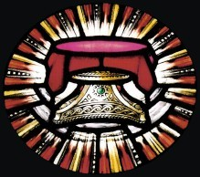
In that book Campbell describes what he believes is the first “secular mythology”: that of King Arthur and his Knights of the Round Table. Originating in Celtic myth and British legend, these tales received momentum from Wolfram von Eschenbach’s influential novel Parzival, written around 1200-10, and from the songs of 12th– and 13th-century troubadours. In their hands, the gods transformed into nobles and knights striving for a better world. Although we might debate the term “secular mythology”—myths start as sacred tales, and the Arthurian are embedded in a Christian context—it points suggestively to a folkloresque storymaking unconstrained by religion or tradition, yet possessing “the value and force of living myth.”
Dream up a set of inspiring stories that fit our time, add ingredients, and cook. Can a meal made from our loreway recipe provide spiritual, philosophical, and psychological sustenance?
Here I have only scattered hints and examples to report. I know a few scientists, philosophers, artists, dancers, ecologists, teachers, storytellers, depth psychologists, and other creatives whose work serves as their spiritual path and primary road to enthusiasm for life. I know some contemporary druids who don’t claim a particular lineage, psychedelic medicine experts, bodywork practitioners who love to learn and share what they know. A colleague who grew up in the Middle East is turning disco into a spiritual path. No belief required. If you dance, you’re in.
The Kalevala is an epic novel of Finnish folktales stitched together by Elias Lönnrot. He went around his homeland collecting orally recited poetry. His book has been hugely influential in giving Finland its sense of identity. That was one man’s creative effort. What would a collaboratively produced Kalevala for the planet be like? Wouldn’t it be amazing for an international network of creatives to try that with myths, folktales, fairytales, and legends found all over the world?
For a long time, I thought my hobby of writing science fiction and magical realism tales entirely separate from my main work, which is terrapsychology: studies, ideas, and practices for reimagining how deeply the things of the world–our surroundings, the elements, buildings, roadways, neighborhoods, even Earth—live inside us, and how often what we consider purely personal aspects of our psychology mirror the state of the world. Academically, terrapsychology is taught in higher ed and used in qualitative research as a particular blend of depth psychology, ecopsychology, Family Systems, storytelling, and other disciplines.
Gradually, I realized that my scribblings, whatever their value, speak in their own way to the terrapsychological goal of fostering just and Earth-honoring forms of community. They express the utopic imagining I teach my students and offer in workshops and videos. I’ve also presented on enchantivism: telling stories more spacious and visionary than the ruptures and injustices that prompted them. As one of my characters puts it: If we can dream it together, we can do it together.
I also realized I was cobbling together the beginnings of a loreway focused on Terrania, the mature and delightful world civilization waiting for us in the future, if only we can make our way there. The fanciful word “Terrania” floated into my consciousness while I walked outside asking myself: What would happen if I imagined the kind of society I’d love to live in, then acted like I already did? If Terrania insists on appearing in my dreams, why not pretend it to be real?
What would happen if a diverse group of us did this kind of “world-conjuring?” Bouncing around some dreams and seeing which of them take hold? I’d like to find out.
One result of these musings has been a series of interlocking stories set in an Assembling Terrania Cycle, a hopeful if fantastic line of development reaching from the Big Bang to the future. I call these stories archetales: tellings that aspire to pack the punch of living myth. I post them online for free, just for fun.
The stories contain mythic figures and folkloric themes from many times and places, all melted down and mixed together to see what emerges. They supplement my nature reconnection practices, direct service to victims of injustice, and ongoing reflections on my spiritual path, which I suppose could be called ecohermeticism or terragnosis, although I seldom think of it in such formal terms. My preference is to play with the images, mythic and otherwise, and let them show up for me as they like.
A loreway wouldn’t be much use for erecting a structure of absolute certainty built to convince and convert. Maybe some people need that. I’m more interested in having friends to play with. The cosmos I live in is not a chaos ruled from a palace or courthouse braced with immovable marble columns. It’s more like an endless Slip N Slide, or a painting whose characters color in themselves, or a sandtray filled with shapeshifting thingamajigs, doohickeys, or whatchamacallits.
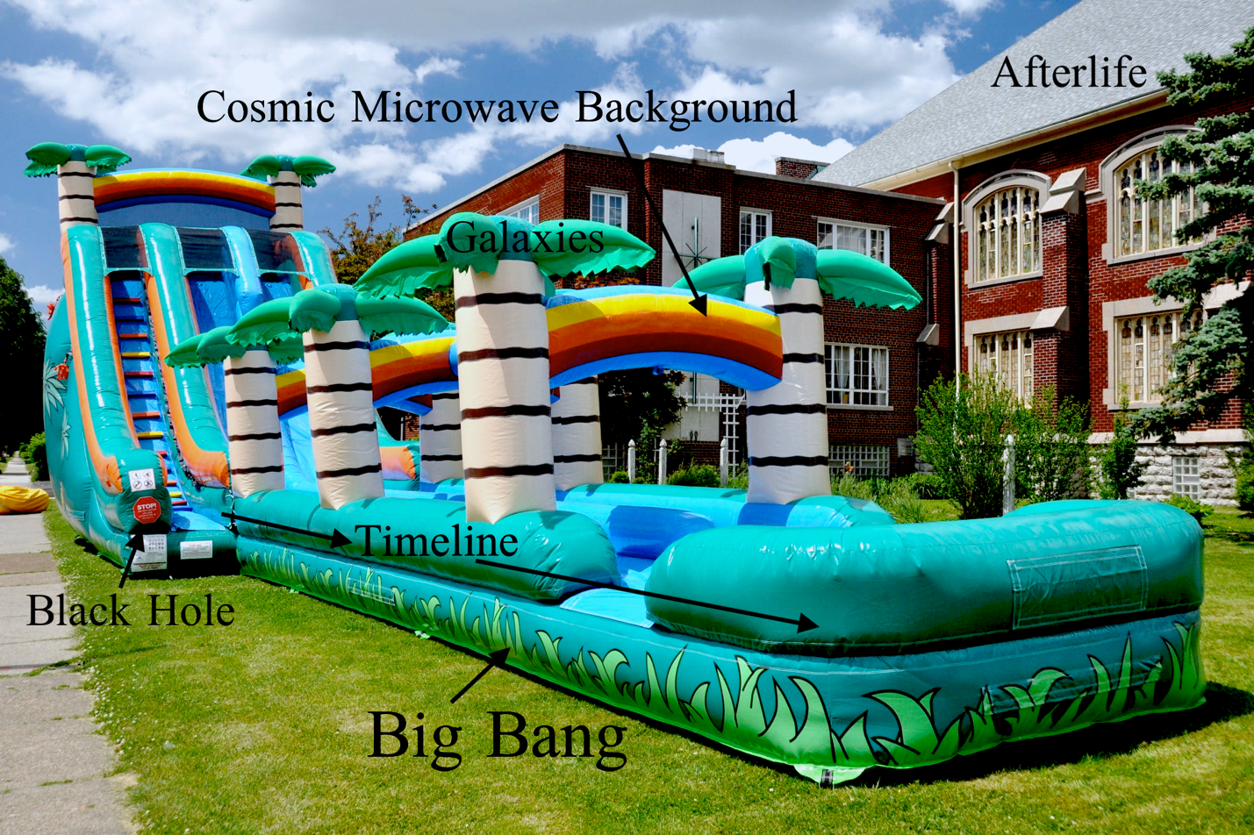
Cosmic Slip N Slide. Dark matter and energy not shown comprise 96% of the picture.
A source of job security for religion has been emphasizing the supposed split between matter and nature. But if we see matter as enspirited, the split collapses. So does the need for institutions built on it. According to the serapiontic principle (1819) of Romantic writer E. T. A. Hoffman, the inner world of the spirit receives its promptings and triggers from the things of the outer world. Their alignment gives off a shining sense of magic in the everyday, outside as well as inside.
Do I believe that cosmic archetypal Powers called the Komuay really exist? A Tetraverse of four layered dimensions, with ours being the most material? A Source at the heart of it all? I don’t believe them. I believe in them.
Back to our question: Do we need a new mythology? Not the kind we’ve already seen. We have all the mythologies we could possibly desire. Needed: not big new stories taken literally or believed in, but brave new storytellers working together to help us dream our way past immaturity, injustice, and violence and on into brighter futures. In other words, an unmythology, metamythology, or trans-literal mythology.
If unfettered by initial considerations of practicality, fantasy unchained holds the potential for creating real change. Films, poems, songs, festivals, and works of fiction demonstrate this every day. Why is the Earth Charter, an exemplary document for moving forward, not more popular? No archetales. No rites of passage. No loreway beyond the charter itself and some personal accounts and educational modules attached to it.
New imaginings can generate billions in profit for a handful of companies, but they can also found movements, overturn empires, announce scientific discoveries, elevate the humble to power and influence, and change millions of minds about why we are here and how we might relate to one another as members of our human family.
No one can predict where the lightning will strike. Imaginings that remake the world begin as humbly as a bored academic looking at a blank page and visualizing the words, “In a hole in the ground there was a hobbit…”


#assemblingterrania #enchantivism #terrapsychology
© 2020 by Craig Chalquist

